**Assignment 3**

**1:1 and Recursive**

Review the Chapter 6 video.

1. East Carolina Bank needs a Personnel database. Use this data model to create the Employee and Department tables. The supervisor relationships are shown on page 2. Include the Foreign Key constraint **for only the "Head" relationship**. The Foreign Key format for MS-SQL is:   
 **Constraint *nameofconstraint* Foreign Key (*nameofFK*) References *nameofPKtable* (*nameofPK*)**Use the Insert statements on page 2 to determine the data types. Make up date of birth and salary for the employees, giving at least one worker a higher salary than his/her boss. (45 pts.)



Create Table Employee (

EmpID int not null,

EmpFirstName char(10) not null,

EmpLastName char(10) not null,

EmpDOB char(10),

EmpSalary int,

EmpBelongsDeptCode char(4),

EmpSupervisorEmpID int,

Primary Key (EmpID))

Constraint

Create Table Department (

DeptCode char(4) not null,

DeptName char(15),

DeptPhone char(11),

DeptHeadEmpID int,

Primary Key (DeptCode),

Constraint FKHead Foreign Key (DeptHeadEmpID) References Employee (EmpID))

Insert Into Employee

values (1,"Sam","Woods","11/1/1942", 275000, "MGMT", NULL)

Insert Into Employee

values (2,"Grace", "Brown","11/2/1942",165000, "LOAN",1)

Insert Into Employee

values (3,"Jason", "Meeks","11/3/1942",155000, "TELL",1)

Insert Into Employee

values (4,"Mary","Alice","11/4/1942", 275000, "LOAN", 2)

Insert Into Employee

values (5,"Alison","Vector","11/5/1942", 110000, "LOAN", 2)

Insert Into Employee

values (6,"Jack","Landry","11/6/1942", 175000, "TELL", 3)

Insert Into Employee

values (7,"Larry","Snow","11/7/1942", 125000, "TELL", 3)

Insert Into Employee

values (8,"Judy","Jones","11/8/1942", 155000, "TELL", 7)

Insert Into Employee

values (9,"Jerry","Moore","11/9/1942", 275000, "TELL", 7)

Insert Into Department

values ("MGMT","Management",8888888888,1)

Insert Into Department

values ("LOAN","Loans",8888888889,2)

Insert Into Department

values ("TELL","Tellers",8888888881,3)

Insert the SQL query following each question. All lists should be sorted. Always use meaningful column headings.

2. Using the Delete command, try to delete Jason Meeks from the Employee table. Since Jason is the head of a department, the Foreign Key constraint should prevent you from doing this. If the delete is successful, the Foreign Key constraint is not correct and will have to be fixed. You will also have to add Jason back to the Employee table. Include this Delete command in your assignment submission. (10 pts.)

DELETE

FROM Employee

WHERE EmpLastName = "Meeks"

3. List each Department name and the name (first and last combined) and DOB of the Employee that heads that Department. (8 pts.) This question uses the ___1:1_________________ relationship. (2 pts.)

SELECT DeptName, EmpFirstName + EmpLastName AS "Dept Head", EmpDOB

FROM Employee, Department

WHERE EmpID = DeptHeadEmpID

ORDER BY DeptName

4. List the employee's name and salary and the supervisor's name and salary of any employee who makes more than their boss (combine their last and first names and use CAST to restrict their salary to two decimal places) e.g. Cast(EmpSalary as Decimal(10,2)). (8 pts.) This question uses the ___recursive______ relationship. (2 pts.)

SELECT wrk.EmpFirstName + wrk.EmpLastName as "Emp Name", CAST(wrk.EmpSalary as Decimal(10,2))as "Emp Salary", boss.EmpFirstName + boss.EmpLastName as "Boss Name", CAST(boss.EmpSalary as Decimal(10,2)) as "Boss Salary"

From Employee wrk, Employee boss

WHERE boss.EmpID = wrk.EmpSupervisorEmpID

AND wrk.EmpSalary > boss.EmpSalary

5. For each department, list the department name, the number of employees, and the total salary budget. (8 pts.)   
 This question uses the _______1:M_____________ relationship. (2 pts.)

SELECT DeptName, COUNT(EmpID)AS "# of Emps", SUM(EmpSalary) AS "Dept Salary Budget"

FROM Employee, Department

WHERE EmpBelongsDeptCode = DeptCode

GROUP BY DeptName

6. List the Supervisor’s Department Name, and Department phone number, Supervisor's name, and Employee's name (combine their last and first names). (8 pts.) This question uses the __________1:M_____ and ___recursive_____________ relationships. (2 pts.) Your output should look exactly like this. (notice the sort order)

SELECT DeptName, DeptPhone, boss.EmpLastName + ", " + boss.EmpFirstName as "Dept Head Name", wrk.EmpLastName + ", " + wrk.EmpFirstName as "Emp Name"

FROM Department, Employee boss, Employee wrk

WHERE boss.EmpID = wrk.EmpSupervisorEmpID

AND DeptHeadEmpID = boss.EmpID

ORDER BY DeptName, boss.EmpLastName, wrk.EmpLastName

|  |  |  |  |
| --- | --- | --- | --- |
| **Department** | **Phone** | **Boss** | **Employee** |
| Loans | 328-9893 | Brown, Grace | Alice, Mary |
| Loans | 328-9893 | Brown, Grace | Vector, Alison |
| Management | 328-9894 | Woods, Sam | Brown, Grace |
| Management | 328-9894 | Woods, Sam | Meeks, Jason |
| Tellers | 328-9899 | Snow, Larry | Jones, Judy |
| Tellers | 328-9899 | Snow, Larry | Moore, Jerry |
| Tellers | 328-9899 | Meeks, Jason | Landry, Jack |
| Tellers | 328-9899 | Meeks, Jason | Snow, Larry |
|  |  |  |  |

**With the results of this SQL query on the screen, press the Print Screen key, put the cursor at the bottom of this document and press ctrl-V to paste it. (5 pts.)**

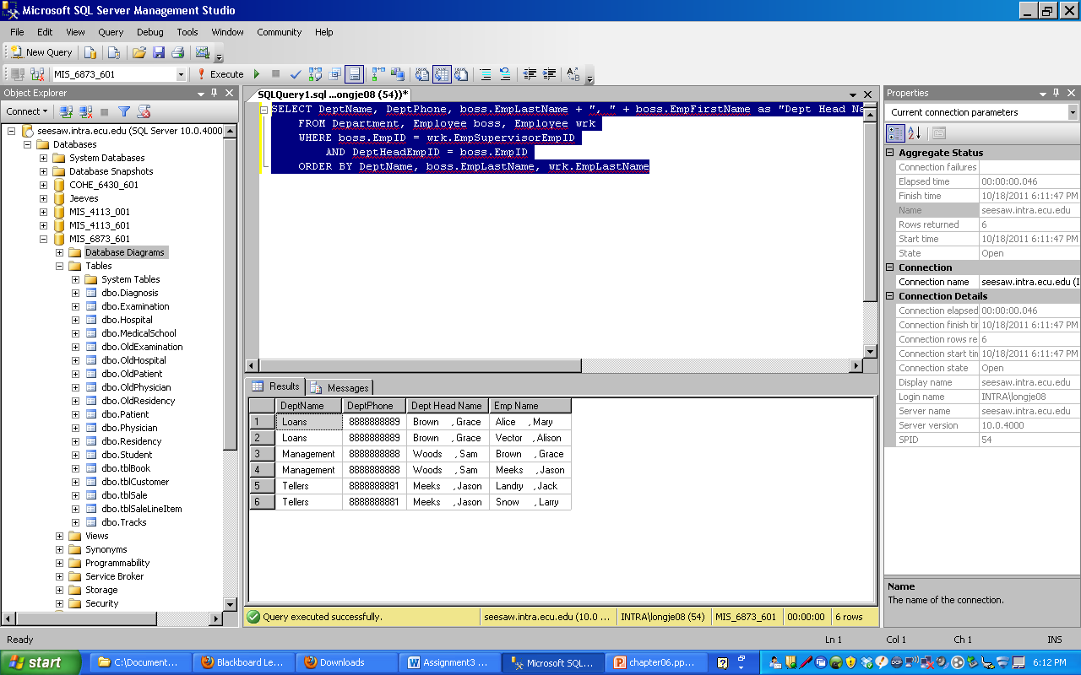

- submit all Create, Insert, Delete, and Select statements and any Update or Alter you may have used. Name this Word file as instructed in the Submission link..

Management

Sam Woods

Loans

Grace Brown

Jerry Moore

Tellers

Jason Meeks

Jack Landry

Larry Snow

Judy Jones

Alison Vector

Mary Alice

**…**

Insert Into Employee

values (1,"Sam","Woods","11/1/1942", 275000, "MGMT", NULL)

Insert Into Employee

values (2,"Grace", "Brown","11/2/1942",165000, "LOAN",1)

Insert Into Employee

values (3,"Jason", "Meeks","11/3/1942",155000, "TELL",1)